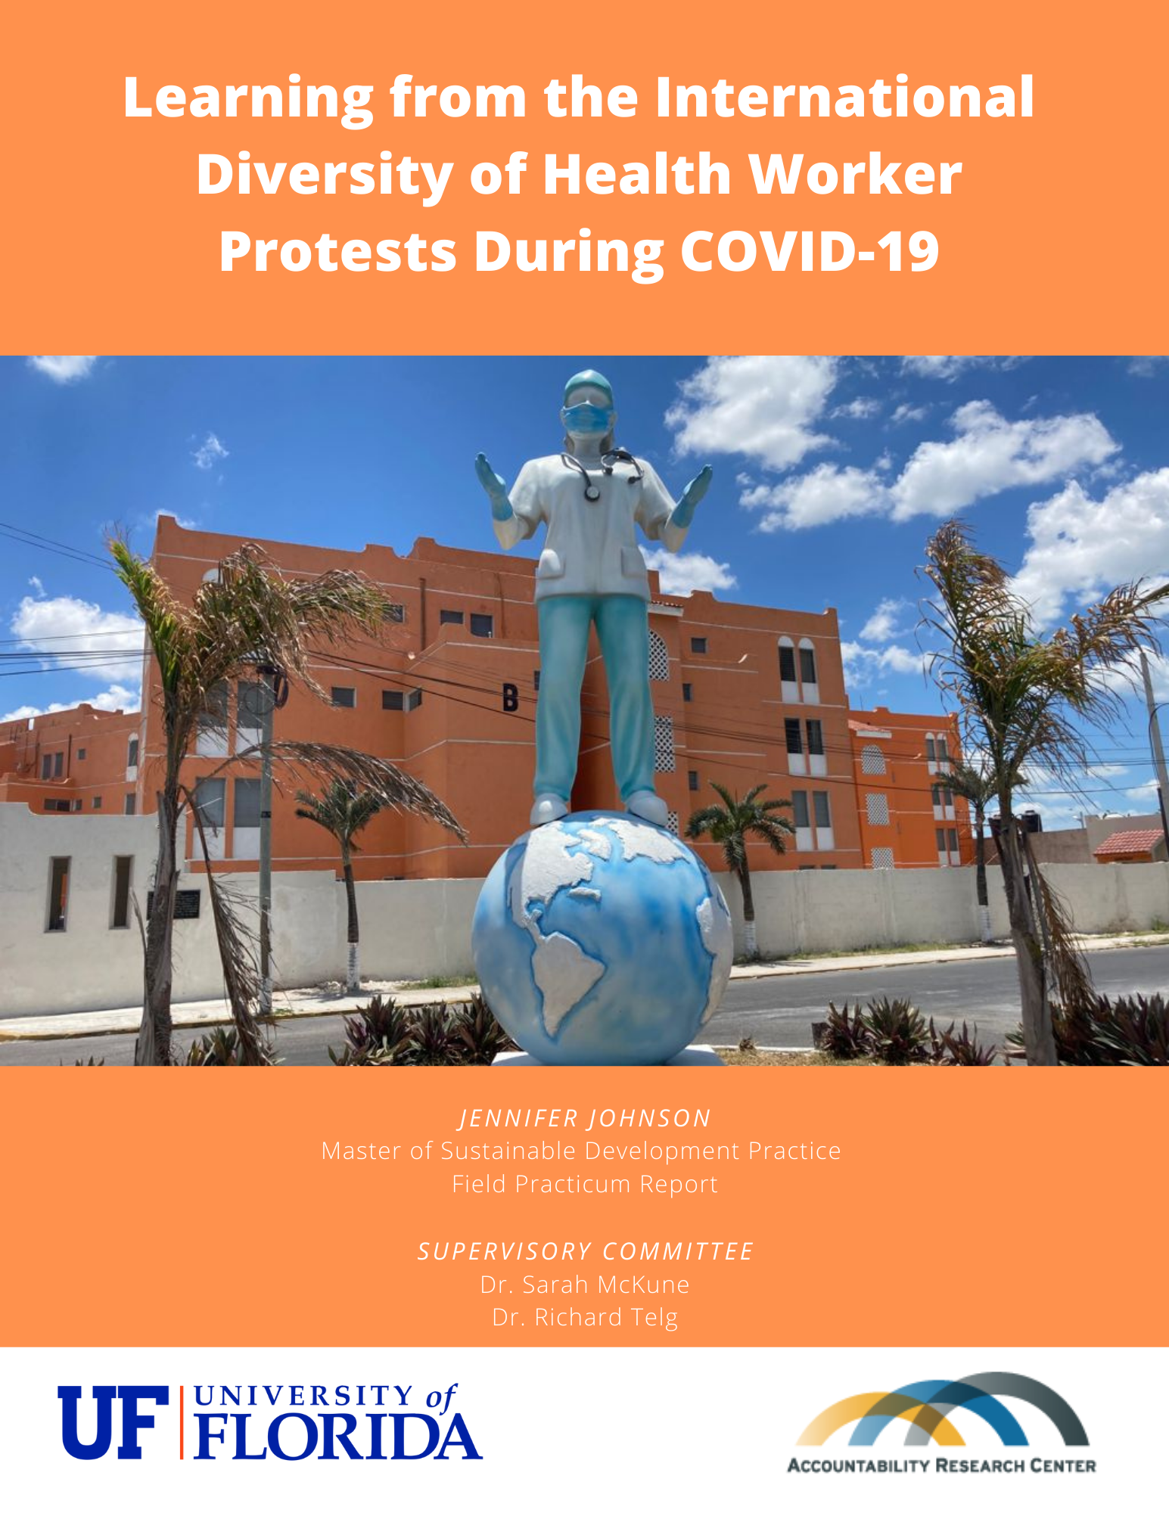

Table of Contents
Abstract 2
Acknowledgements 3
Introduction 3
Host Organization 4
Context and Background: Health Worker Protests During COVID-19 5
Geographic Context 6
Literature Review 7
Methods and Analysis 8
Results 9
Demands: 10
1.) Compensation and Job Security 10
2.) Resources 12
3.) Work Conditions 14
4.) Health System Critique 17
5.) Social Issues 17
6.) Government Restrictions 19
7.) Other 20
8.) Delivery Organization 21
Conclusions 22
References 23

Abstract
The COVID-19 pandemic gave rise to new risks and challenges to health workers, and exacerbated other pre-existing challenges within health systems. This complex situation launched a new wave of health worker protests around the world, as health workers demanded accountability from their employers and governments for the challenges they faced on the front lines of COVID -19. This research project analyzed the demands expressed in media reports about health worker protests during COVID-19, in order to learn more about the challenges health workers faced during the pandemic. Findings indicate that the main demands around which health workers organized protests included compensation and job security (mentioned by 45% of all protests), resources, such as personal protective equipment (PPE) and vaccinations (41%), followed by improved working conditions (30%). By analyzing health worker demands, this study aims to inform policy that better supports health workers to do their jobs safely in this pandemic and beyond.

Acknowledgements
To Dr. Jonathan Fox. Thank you for recognizing the need for this work, and for allowing me to join your team for the Health Worker Protest Project. From serving as my undergraduate capstone advisor to shepherding me along my graduate field practicum, your guidance has been invaluable. To Dr. Naomi Hossain. Thank you for serving as my host organization supervisor, for so many hours of zoom calls and support, and for constantly helping me center this work on the people and topics that matter most. To Angela Bailey. Thank you for your constant communication and support. I will be eternally grateful to you and the entire team at the Accountability Research Center. Many thanks to ARC interns Daniela Flores-Briggs and Rehana Paul for their invaluable support for the HWP project. To everyone who contributed to crowdsourcing health worker protest and proposal media reports from around the world. Thank you for helping make health worker voices heard. To Dr. Veena Sriram and Dr. Sorcha Brophy. Thank you for taking such an interest in the health worker protest project, for all of your incredible research contributions on this topic, and for your constant encouragement and advice.
To Dr. Sarah McKune. Thank you for believing in me from the start, and for agreeing to be my field practicum advisor. Your incredible knowledge and advice over Zoom each week kept me sane and on-track for months before we ever had the chance to meet in person. To Dr. Richard Telg. Thank you for lending your communication expertise to help me better communicate the results of this field practicum to the world. To Dr. Glenn Galloway, Dr. Andrew Noss, and the entire MDP Program and Faculty. Thank you for your constant insight, guidance and support, and for giving me the opportunity to participate in this incredible program. To my parents. Thank you for hosting me during my virtual field practicum in a pandemic, and for your unconditional love and support not only during the data entry phase of this practicum but over my entire life. I love you so much. To my partner, Omar. Thank you for your constant inspiration, Spanish translation assistance, love and support.
Above all else, this practicum is dedicated to all health workers around the world for their work and sacrifice during the COVID-19 pandemic. There are not enough words to thank you for risking your lives to save ours. Thank you for your bravery in raising your voices and sounding the alarm on the impossible challenges you have faced during this pandemic. We hear you, we see you, and we promise to work to do better. In memory of the thousands of health workers who lost their lives in this pandemic. You will not be forgotten.

Introduction

On March 11th, 2020, COVID-19 was declared a global pandemic. In the nearly two years since, health workers around the world have faced inordinate risks in order to continue working, risking their lives in order to save others. At the same time, they have often not been given the tools and working conditions they need in order to do their jobs safely, including personal protective equipment (PPE) and access to life saving vaccines. Some have been forced to work without pay, or under working conditions that they feel compromise their safety. This evolving situation has given rise to a new wave of hundreds of innovative protests and proposals from health workers on the frontlines. The Health Worker Protest Project is a pilot learning initiative from the Accountability Research Center (ARC) looking to learn from the international diversity of health worker protests and proposals, coronavirus related and beyond. In the first year of the pandemic the project compiled 844 reports of health worker protests and proposals from 96 countries through crowd sourcing and shared them on social media via the twitter account @HealthWorkerPro in order to raise awareness of the challenges faced by health workers during COVID-19. For my field practicum I analyzed these demands using the qualitative analysis methods, document analysis and content analysis, in order to better understand the needs and demands health workers were expressing in their protests.

Host Organization

The Accountability Research Center (ARC) is an action-research incubator based out of American University in Washington, DC. ARC partners with civil society organizations and policy reformers in the global South to contribute to research and practice in the field of transparency, participation, and accountability. Their main goals are to help improve the organizational effectiveness of their partners, as well as to inform agenda setting within the global transparency, participation, and accountability field. ARC engages with a wide range of civil society thinkers, activists, practitioners, policy reformers and academics working on accountability in many sectors and geographies. Through extensive dialogue with partners and collaborators, they seek to co-design exploratory research that is relevant for their strategies and can contribute to international thinking about how change happens. At the beginning of the COVID-19 pandemic, ARC was concerned by accountability failures putting health workers at risk and leading to health worker protests and proposals around the world. They launched the Health Worker Protest (HWP) project in order to learn from any patterns that emerged through review of the diversity of health worker protests and proposals occurring globally. The proposition was that recognition of health worker voices and actions would shed light on a wide range of accountability failures in public health and governance systems, as well as on their proposals for how to improve public health systems. ARC used their extensive network to launch a crowd sourcing movement, seeking media reports on health worker proposals from around the world. Through their work and outreach via their website, newsletter and social media, nearly 850 reports were compiled in little over a year. ARC initially hired me as a research communications consultant to launch the HWP, track and compile all media reports received, and manage the HWP twitter account to share all reports received and spread awareness on the accountability issues driving health worker protests around the world. They graciously agreed to serve as the host organization for my virtual field practicum, allowing me to dive deeper into the data found within the media reports on health worker protests and proposals. I collaborated with the organization via Zoom during the duration of the field practicum, and I was able to meet with the ARC team for the first time in person for a health worker protest project meeting on June 14, 2021 at American University in Washington DC.
Dr. Jonathan Fox, founder and director of ARC, launched the HWP project in May 2020 and provided invaluable support and guidance in the creation and formulation of this practicum and the surrounding research questions. Dr. Naomi Hossain, research professor at ARC, served as my host organization supervisor and maintained constant communication and support, helping me to center my practicum and research on the most important and relevant questions and accountability challenges. Dr. Veena Sriram, University of British Columbia, and Dr. Sorcha Brophy, Columbia University, led a parallel research project on health worker protests during the COVID-19 pandemic using The Armed Conflict Location & Event Data Project (ACLED) database. They also provided constant guidance and support in the creation and analysis of my practicum data, especially in the creation of themes and codes. The results of their research were recently published by ARC in the Accountability Note “Heroes on Strike: Trends in Global Health Worker Protests During COVID-19” (Brophy et al., 2022). Additional information on the Health Worker Protest Project and related research can be found on the Accountability Research Center website here.

Context and Background: Health Worker Protests During COVID-19

Health workers around the world have faced unprecedented levels of risk during the COVID-19 pandemic. Nurses, doctors, community health workers and other hospital staff have been at the frontlines for over a year, risking their own lives to protect others. There has been significant public appreciation for health workers, from collective balcony clapping to murals and social media campaigns. However, throughout the pandemic, health workers have often not received the basic things they need to do their jobs, including PPE, safe staffing, quarantine facilities, or even their own salaries. Many have had to resort to more and more desperate ways of making their voices heard, through various forms of protests and proposals.
As COVID-19 makes it dangerous to congregate in large groups of people, health workers have become creative in their forms of protest. Online protests have allowed many health workers to express their needs, concerns, and demands while still social distancing. In the “naked doctor” protests of Argentina, France and Germany, health workers posed nude on social media to represent how vulnerable and unprotected they are on the frontlines without adequate PPE. Several innovative protests stand out from the reports compiled by the Health Worker Protest Project, from health workers in France holding a “dancing protest” for better working conditions, to a Doctor in India attending patients outside as a form of protest against non-functioning air conditioning and unhygienic conditions inside of the hospital. Health workers in Canada recently delivered hearts made of ice to their local government, to call them out for their cold heartedness in not listening to them or responding to their demands.
While not included in the final analysis, the “proposals”, any media reports including health worker concerns, complaints, demands, suggestions, or reports of violence against health workers that we received via crowdsourcing that did not meet the inclusion criteria as protests, provided important background information to the context the international protests were occurring in. One such case is the media report of the death of 28 year old doctor Adeline Fagan, who died of COVID-19 after being forced to wear the same N95 mask for weeks on end due to lack of supplies of PPE. Another “proposal”, “lost on the frontline”, a database compiled by The Guardian of all health worker deaths due to COVID-19 in the United States, found that about one-third of the deaths involved concerns over inadequate PPE. Other reports did not necessarily reflect organized protests but included the pleas of health workers physically and mentally exhausted by the pandemic: “I'm a good nurse — and the nurses I work with are good nurses — but we are broken.”
It is important to note that in many cases, a lack of protests do not necessarily mean a lack of issues - protests are more likely to occur where there are legal protections allowing peaceful protest, or where people feel they may be heard. Health workers may want to protest but could be afraid of losing their jobs or facing retaliation, or even of being arrested or facing violence from the police. COVID-19 was also both a cause and restraint – several media outlets reported on planned protests that were unable to occur because of government implemented COVID-19 social distancing guidelines.
Despite the great risks involved, around the world thousands of health workers managed to find innovative ways to protest and express their needs and demands during, and in spite of, the COVID-19 pandemic.

Geographic Context

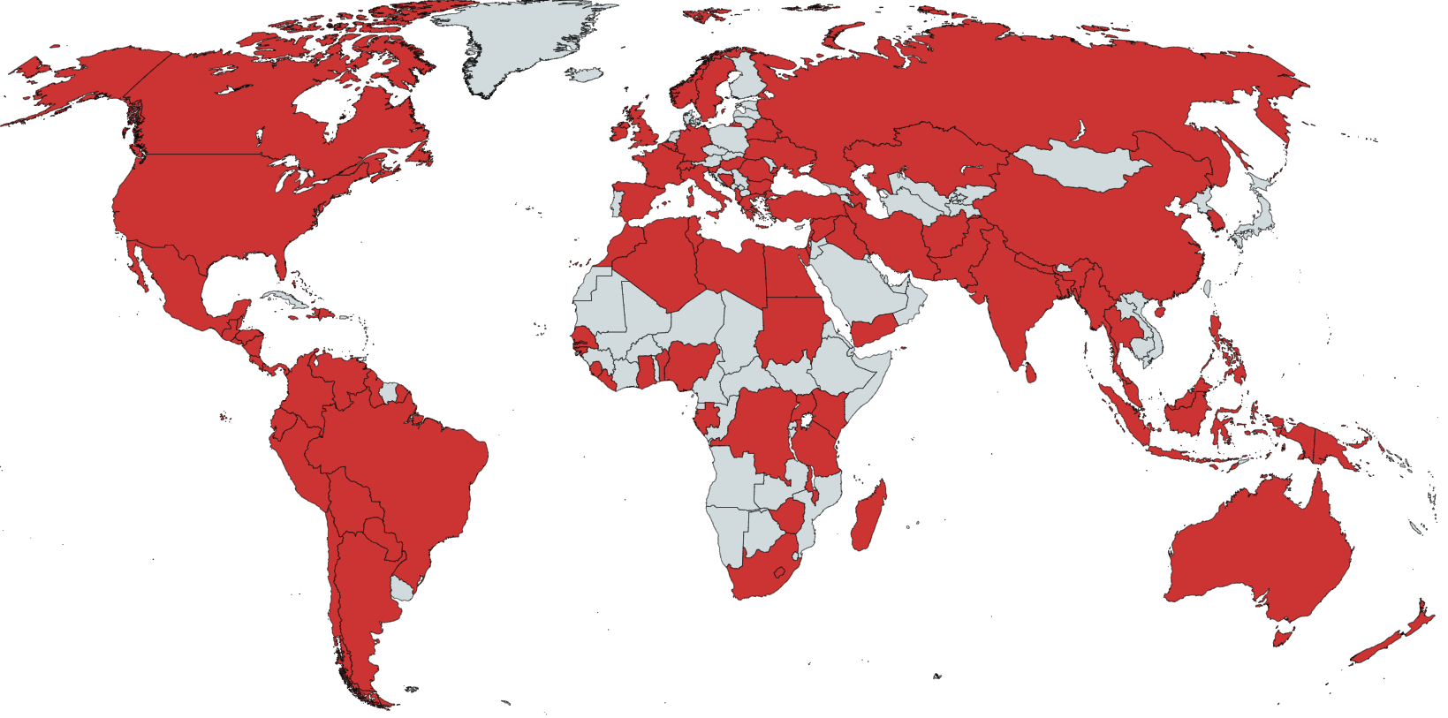
Figure 1: World map showing every country we received a health worker protest or proposal report from during the health worker protest project.

Over the first 13 months of the Health Worker Protest Project, we received 841 health worker protest and proposal reports from 96 counties. As shown in the map above, these reports span every continent and geographic region. The countries we received the most reports from included the United States (169 reports), India (78 reports), Mexico (65 reports), Nigeria (29 reports), South Africa (28 reports), Philippines (27 reports), Pakistan (26 reports) and the United Kingdom (25 reports). This does not necessarily mean that these countries had the most protests, but could reflect the geographical regions of and languages spoken by ARC stakeholders from accountability-related organizations based in the US, Mexico, Guatemala, Philippines, India, and other countries that participated in the crowdsourcing initiative, or the countries and protests that were able to attract the most media attention. Crowdsourcing collaboration was requested via email, the ARC newsletter, ARC social media accounts, and the Health Worker Protest Project twitter account (@HealthWorkerPro), which may have also affected the geographic distribution.

Literature Review

While health worker protests during COVID-19 are a recent phenomenon, the needs and demands behind their protests are not new, nor is it the first time that health workers have protested against accountability failures they face in their work. A 2019 study on health worker strikes in lower income countries found that the most commonly reported cause of strikes was complaints about remuneration or compensation, followed by protest against the sector’s governance or policies, as well as safety of working conditions. The study concluded that health sector strikes are context-specific, but also share some commonalities, and that health worker unions and professional associations often played a role in organizing strikes and protests as well as reaching positive resolutions (Russo et al. 2019). Another study conducted in Nigeria in 2018 determined that the main causes of local health worker strikes and protests were poor staff welfare, salary and leadership/management and governmental inability to implement agreements. The study found that these strikes resulted in disruption to service delivery and training programs, as well as increased morbidity and mortality of patients and loss of confidence in the hospitals and the healthcare professions (Oleribe et al. 2018). While the longstanding systemic issues surrounding health worker protests and strikes have been made worse by COVID, they may also have made COVID worse – Essex and Weldon (2021) argue that health workers lives were put at greater risk due to government neglect, underfunding, and lack of preparation for a pandemic that had long been forewarned.
Failing to listen to health workers on what they need in order to do their jobs safely could spell disaster for healthcare systems worldwide. Shah et al. (2021) found burnout to be a major contributing factor to nurses leaving their jobs even before the pandemic. Of the over 400,000 nurses who left their jobs in 2017, 31.5% cited burnout as one of their reasons. Among all nurses who reported leaving their jobs due to burnout, 68.6% also reported a stressful work environment, and 63.0% reported inadequate staffing. As nurses makeup a large percentage of the healthcare workforce both in the United States and around the world, these reports are extremely concerning, as losing nurses due to burnout would drastically impact health systems ability to provide patient care, especially during a pandemic. The study recommended that health systems implement strategies to prevent and alleviate burnout in nurses, such as ensuring adequate staffing and limiting hours worked per shift (Shah et al, 2021). These changes to improve working conditions could have outsized results - Copanitsanou et al. (2017) reported that nurses who considered their work environment to be good experienced lower rates of burnout syndrome and reported higher job satisfaction overall.
In addition, studies have shown that higher levels of nurse burnout are associated with lower patient satisfaction with care, and that 50% of hospitals that report high burnout are also considered to have poor work environments (Brooks et al. 2021). Schlak et al. (2021) found that hospitals with higher nurse burnout scores also had higher patient mortality. A study on nurses in Malaysia found that a higher workload was associated with unfavorable outcomes, and that nurses working longer hours were less likely to report a favorable practice environment (Jarrar et al. 2021). The study suggested that improving the working environment for nurses could improve nursing care and prevent patient harm, a win-win situation that would strengthen the health system overall.
A 2020 study based on a survey of health workers at 25 medical centers in the United States found that COVID-19 pandemic put health workers at increased risk of adverse mental health outcomes such as alcohol abuse, post traumatic stress disorder, anxiety and depression. The study also found that increased workloads, difficulty accessing PPE, and traumatizing patient care experiences greatly impacted health worker experiences during the pandemic. (Hennein and Lowe, 2020). Another study on health care workers during the COVID-19 pandemic found health worker burnout to be alarmingly high, and recommended that health care worker wellbeing be made an organizational priority (Rehder et al. 2021). Health workers are at the core of all health systems, and must be protected in order to protect patients.

Methods and Analysis

The methods that I used in my field practicum were document analysis and content analysis of media reports collected by the Health Worker Protest Project (HWP). Content analysis is a qualitative data analysis approach used to determine trends and patterns in textual information (Vaismoradi et al., 2013). I chose this method in order to dig deeper into the qualitative data available in the HWP media reports, in order to gain a better understanding of the demands behind the health worker protests. The media reports were collected via crowdsourcing of ARC contacts on twitter and via email, as well as google alerts on topics related to the media reports we were trying to compile, including “health worker protest” or “PPE protest”. Originally reports were collected that reflected either health worker protests or proposals – any health worker complaints, demands, suggestions, or reports of violence against health workers. Overall we received 841 health worker protest and proposal reports from 96 countries. All reports received were extremely relevant and important, both those that reflected protests and proposals, but for purposes of analysis and being able to compare similar variables between reports I limited the analysis to protests only. The inclusion criteria was that the media report reflected an organized protest, whether in person or via social media. I also limited my analysis to reports on protests that occurred between March 11 2020 to March 10 2021, the first full year after Covid-19 was declared a global pandemic. Only text-based media reports were included, not reports that were only videos, photos or social media posts without textual accompanying information fitting the inclusion criteria. Lastly, I also only included media reports in which a specific date was given for protest, and media reports where the article still exists.
I then conducted document analysis and content analysis, manually going through each media report to determine if it fit the inclusion criteria and recording the variables that would be analyzed. For the content analysis I identified the parts of the media report that specifically referred to protest demands, and coded them based on the category they described. I used the same codes as another research team led by Dr. Veena Sriram and Dr. Sorcha Brophy working on health worker protests from the ACLED database, to allow for eventual comparison of our datasets. The codes used were resources, work conditions, delivery organization, government restrictions, health system critique, social issues, and other.
Any demands for things that were required for health workers to deliver care safely were coded as “resources”. This includes any mentions of personal protective equipment (PPE), including masks, gloves, and other biosecurity equipment, as well as training, protocols, biosecurity/safety, data, supplies, testing providers, vaccinations. Anything affecting health workers ability to work or impacting their work environment was coded as “working conditions”, including mentions of being overworked, understaffed, having bad management, arrests of providers, violence toward providers, security in facility, unsafe or insufficient infrastructure, and or punishments for attacks. Any demands health workers mentioned about their payment or employment were coded as “compensation/job security”, such as delayed or unpaid salaries, demands for extra pay, salary reduction, risk allowances, unemployment pay, insufficient pay, benefits, formalization of contracts/regularization, legal protections, labor (union) negotiations, insurance suspension of licenses/permits, marginalization, land, contract renewal, status, title, delivery of diplomas, dismissal, recognition as govt employees.
“Delivery organization” refers to health worker demands around conversion to COVID facility, requisition, creation of isolation center, patient overload, transfer of patients, closures, inclusion in new facility, relocation of unit, staff/patients moved, advanced warning re: patients and inclusion in planning process. “Government restrictions” encompasses stay-at-home orders, border closure, mandatory quarantine, weakening of guidelines/restrictions, accommodations/exemptions from restrictions and public behavior. “Health system critique” is the code used for spending (underfunding), privatization, policies/reforms, management of public hospitals, discrimination, services in rural areas, alternative medicine, public health investment, poor state of health system, resources for public hospitals, services, facility quality, regional health infrastructure, availability of patient care, vaccine supply/process and COVID testing for population. “Social issues” refers for health worker protests that were not about health care or the COVID-19 pandemic but rather about other issues happening in their region and society such as climate change, police brutality, elections, military coups, embargoes, release of political prisoners, immigration, prisoners or unjust arrests. “Other” included topics that did not fit in other codes/categories such as respect or recognition for health workers.
In addition to the context analysis on health worker demands, I also collected information for each media report on the media outlet that published the report, the date the article was published and the date of each protest, and the country the protest occurred in. If the report met the requirements for inclusion, I also recorded the health worker profession that participated in each protest, any additional “protesting bodies” involved (unions or professional organizations), who the protest was targeting (government or employer/hospital administration), protest demands and their respective codes, the type of protest, and any direct quotes from health workers involved in the protest included in the media reports.

Results

Of the original 841 health worker protest and proposal reports, 397 fit the inclusion criteria to be analyzed as part of this study. Of these, 164 (41%) included resources as a demand, and 100 (25%) of these specifically mention PPE. This means that a quarter of all protests crowdsourced by the health worker protest project were at least partially about PPE. 41 protests (10%) only listed resources as a demand, of which 28 (7%) specifically mention PPE.
180 protests (45%) include compensation as a demand, whether demanding payment of missed salaries or bonuses, or salary increases due to increased risks, or requesting greater job security to protesting for greater job security or against upcoming layoffs, among other related topics. Of these, 72 (18%) protests only had demands related to compensation.
121 protests (30%) mention work conditions as a catalyst for protests, of which 23 (5.7%) only mention demands related to work conditions. 15 protests (3.7%) mention government restrictions, of which 7 only mention government restrictions. 47 protests mention health system critiques, of which 8 only mention health system critiques. 9 protests mention delivery organizations, of which none only mention delivery organizations. 31 protests mention social issues, of which 29 only mention social issues. Lastly, 12 protests mention “other” demands, the code for demands that call for health worker respect or recognition, or recognition of health workers who have died during the pandemic.
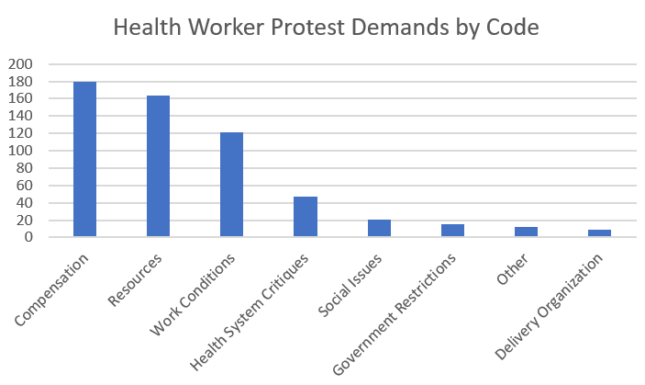
Figure 2: Health worker protest demands by code

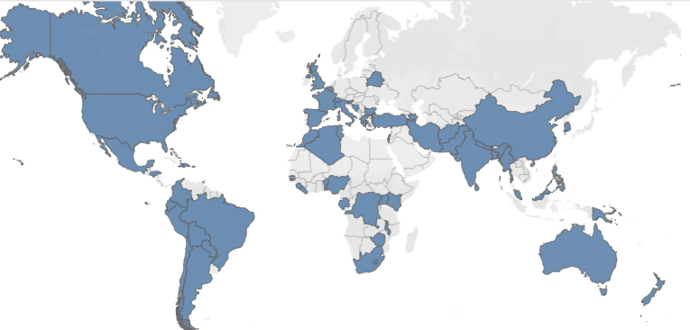
Figure 3: Health worker protests by geography. Source: Jennifer Johnson. This map shows the geographic distribution of the 397 protests that met inclusion criteria to be analyzed.

Demands:

Compensation and Job Security

Compensation and job security was the most commonly referenced demand in health worker protests, as it was mentioned in 180 out of 397 media reports on health worker protests (45%). Many health workers had already gone months without receiving their salaries even before the pandemic began. Others were promised bonuses or pay increases that never came, despite their work risking their lives on the front line. This was especially harmful in countries where many health workers were already making very low salaries. “The majority of nurses are from poor backgrounds and are breadwinners in their respective homes, therefore COVID-19 has also deepened their financial strain and plunged them into poverty because their little salaries have to be shared among a multitude of family members,” said one South African nurses’ union in a statement published on one of their protests.
Other health workers were concerned about their job security, or their irregular status as health workers without contracts or not officially integrated with or paid by the national health system. “We have been ignored for far too long and we are tired. We want danger allowance because we are also in the frontline,” said a community health care worker in South Africa taking part in a protest demanding to be integrated into the Department of Health.

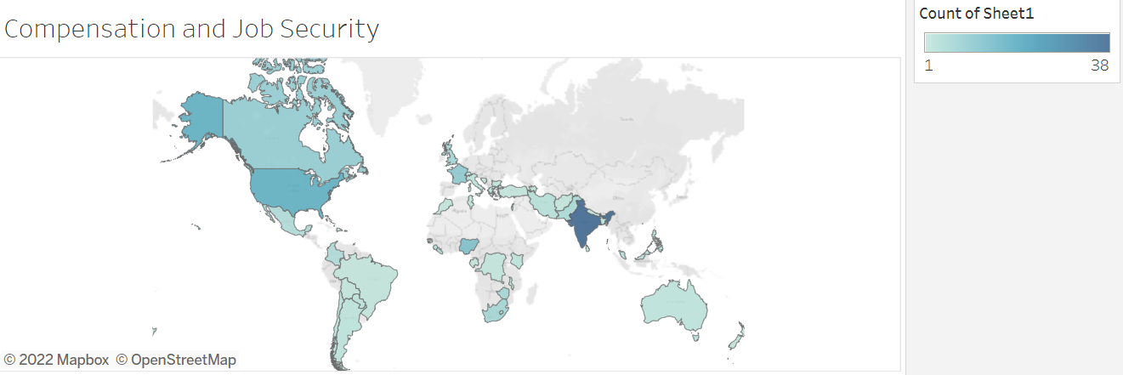
Figure 7: Geographic distribution of media reports of protests mentioning demands related to compensation and job security. For an interactive version of this map, please click here. Source: Jennifer Johnson
In terms of geographic distribution, the country with the highest amount of media reports on protests demanding compensation and job security was India with 38 media reports, followed by the United States with 18 media reports and Nigeria with 13. Overall, protests with demands relating to compensation and job security were reported in 50 countries.

COMPENSATION AND JOB SECURITY
Country | Health Profession | Quote
Canada | Health Workers | “We take the sickness to our families, we worked the overtime hours and we get nothing, we are frustrated.”
Chile | Health Workers | “They want the crisis to be paid for by those who are risking their lives fighting the pandemic.”
Greece | Health Workers | "We need more hospital staff and doctors because they aren't enough. What they are saying is a lie. There are no full-time jobs and the national health system is collapsing."
India | ASHA Community Health Workers | “The ASHA workers work for at least 4-5 hours daily but are being paid only Rs33 (USD $.43) per day. A majority of the workers are from poor families. The government should give an allowance of Rs 3,000 (USD$40.00) per month during the pandemic.”
India | Nurses | “Some of us who were expecting, say, Rs 35,000 for May received Rs 22,000. We work endlessly without complaining, risking our lives, spending up to 12 hours in PPEs without relieving ourselves and even during our periods. They take an account from us for every triple-layer mask, taking our signatures for every little thing, and yet they cannot pay our salaries?”
India | Health Workers | "The government hails us as Corona warriors but do not treat us like one. We all have families. Many amongst us have taken loans, live on rental accommodation, and have children whose schools and colleges are demanding fees. How would we incur our expenses when we are not paid? We repeatedly asked the corporation to clear our dues, but our requests fell on deaf ears. We don't have any option but to go on protest."
India | ASHA Workers | “For working from 7 a.m. to 5 p.m. we get only 2,000 rupees ($27) a month and no masks or sanitizer,”
India | Nursing, paramedic staff | “We stopped work from today and launched an indefinite strike as our salaries are pending for the last four months. We were last paid in September.”
South Africa | Health Workers | "The Department of Health doesn't recognise us. I came out today so that we can be recognised and get what we deserve."
Turkey | Health Workers | “We are calling on the authorities; please be fair and when this epidemic is over, execute a wage policy which will have an effect on the base salaries [excluding supplementary payments].”
United States | Medical center support staff | "We have employees here that have been out sick for a month from COVID that they got from this hospital and they lost all of their vacation time and some of them have even lost their benefits because they can’t pay it because they’ve been out."
Zimbabwe | Hospital workers | “We were taken by surprise that at a time when we expected the government to increase salaries because of inflation, they decided to slash our meager earnings. We want money that can buy [protection] so that we can satisfactorily deal with COVID-19 coming from our homes.”
Zimbabwe | Nurses | “I cannot work for nothing, I have to eat and I have to be mentally healthy so that I can assist the sick.”

Resources

Resources were the second most mentioned demand of the health worker protests, at mentioned by 164 of 397 reports (41%). Of these reports, 100 (25%) specifically mention PPE. There have been widespread shortages of medical masks and respirators in many countries during COVID-19. Many health workers have been forced to use the same mask for extended periods of use or re-use, despite the fact that medical masks can become contaminated and a source of infection, and are recommended to only be single-use (Chughtai et al. 2020). In one hospital in South Africa, nurses were given only one mask per week, and were expected to wash their own PPE at home despite the potential risk of spreading the virus to their family. In India, an accredited social health activist (ASHA) community health worker reported being given only one mask in four months, despite having to interact with dozens of people each day as part of COVID tracking efforts. Health workers across the US have expressed concern at lack of supplies or being asked by hospitals to re-use PPE, or even use PPE that has been “sanitized” for re-use. Around the world, many health workers had to purchase their own PPE, if they could find it, or wear ill-fitting or improper PPE supplied by health systems that did not meet PPE standards laid out by the World Health Organization. “We are protesting our dissatisfaction with equipment such as masks that don’t comply with the quality or protection to provide safety. These don’t have appropriate sealings over the nose and mouth. If we get sick, who will see the patients? Also, the provision of PPE is restricted. Only one or two masks a month for COVID-19 areas and hospitalization,” said a nurse in Peru taking part in a health worker protest over PPE.

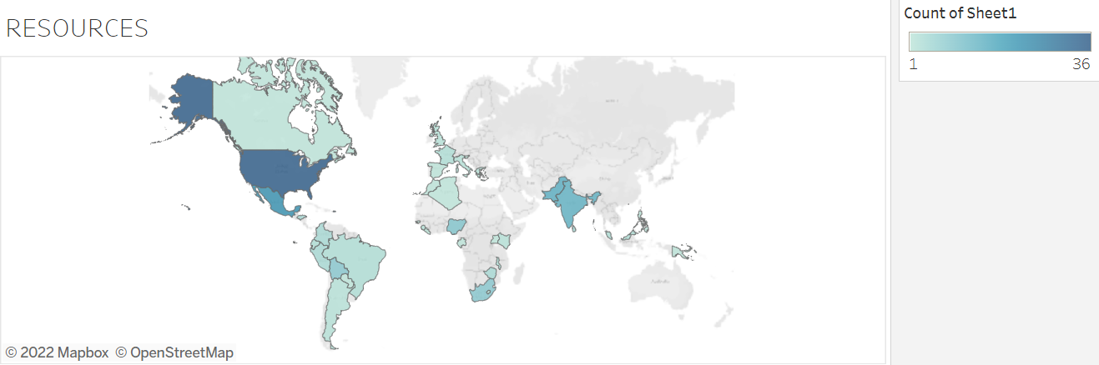
Figure 11: Geographic distribution of media reports of protests mentioning demands related to resources. For an interactive version of this map, please click here. Source: Jennifer Johnson

Health worker protests with demands related to resources were reported in 37 countries, with the majority of media reports coming from the United States with 36 protest reports, followed by Mexico with 23, Pakistan with 16, and India with 15. Nigeria had 10 media reports on protests, while Bolivia and South Africa had 9 each respectively.

RESOURCES
Country | Health Profession | Quote
Ecuador | Doctors, nurses, administrative staff | “This is not a political protest, we just want to be guaranteed safety standards in food, biosecurity suits (PPE), we have to wear the same apron to our homes.”
India | ASHA Workers | “We are working at the ground level and helping people, but getting humiliated instead. We are not getting masks, hand gloves or sanitizers. There are no facilities for us.”
India | Nurses | "I have worked here for two years now, and the past three months have been a nightmare. I do not eat for 12 hours at a stretch as we continuously have patients to cater to. We have repeatedly demanded decent PPE kits, but in vain.”
Paraguay | Health workers | “We don’t have thermometers or biosafety suits, and we have to use the same masks for over 12 hours. We can’t stop taking care of the people, but we are very exposed.”
Peru | Health workers | “We have only 3 masks to use in a month, so we have to re-use them and re-use them, so, what has happened? My colleagues have become infected.”
Peru | Health workers | “We are protesting our dissatisfaction with equipment such as masks that don’t comply with the quality or protection to provide safety. These don’t have appropriate sealings over the nose and mouth. If we get sick, who will see the patients? Also, the provision of PPE is restricted. Only one or two masks a month for COVID-19 areas and hospitalization.”
South Africa | Nurses | "We don't have proper PPE and we are being exposed to the virus. We are fearing for our lives because we can be like our colleagues that have passed away.”
United States | Nurses and nurse technicians | “I feel like they don’t care about our safety. I feel like they are doing what is best for the organization financially not for the staff. The patient ratios are critically high to the point where we are not able to provide quality care to the patients or safe care to the patients. The patients are asking me why am I not wearing what they would call a moon suit. They are asking me where is my equipment? I say ‘This is all they are giving me.”
United States | Nurses | "There’s not enough of it. We're reusing masks when we shouldn't be. We're using N95 much longer than what the manufacturer has made those supplies to last."
United States | Nursing home workers | “I don’t feel protected. I don’t feel safe. It’s terrifying. We have to beg for masks. I work five days a week, and they issue me one mask.”

Work Conditions

Work conditions were mentioned among demands at 121 of 397 protests (30%). This includes concerns such as safe staffing (an appropriate ratio of health workers to patients), as well as working hours and the number of hours on shifts, made more strenuous during COVID in situations where health workers could not eat, drink, or use the bathroom for hours at a time due to inability to remove PPE. “The Corona warriors wear Personal Protection Equipment (PPE) kits for at least 6 hours at a stretch. They are supposed to drink less water in order to stop them from (urinating) time and again, at times they wear diapers and then work. Due to such extreme work conditions, the nurses had been complaining of health issues to AIIMS administration but in vain. This is why they staged a protest and demanded a solution,” cited one media report in India. “When I say I work 13 hours and I don’t get a drink of water, I’m not exaggerating. And, you know, I’m almost 52 years old and I’m a strong lady but I’m not that strong anymore,” said a registered nurse in the United States. “It breaks my heart. The things sometimes that I see I can leave in tears. I have left in tears,” Martin said.
In addition, working conditions also included the state of infrastructure and facilities in the hospital. Some protests stemmed from impossible working conditions in hospitals with broken air conditioning systems, or hospitals not providing quarantine facilities or safe places for health workers to put on and take off protective gear. “How the doctors are supposed to perform a task in PPE suits without AC in the scorching summer heat? It’s a fundamental thing to do. Also, we are not provided for the accommodation facility after duty hours. We work at a high risk while treating COVID-19 patients, going home in such condition would be a great risk for our families. We can’t jeopardize their safety,” said one protestor in India.
Work conditions also included references towards violence against health workers. Some health workers faced violence from members of the public who feared they were a source of contagion, while others faced violence from patients’ family members who felt that they had not done enough to save their loved ones. Other health workers participating in protests have also faced attacks from their local police in many countries, including Pakistan and Iran. Police filed a report against ASHA workers in India for a peaceful sit-in protest on the grounds that it defied lockdown rules, despite the fact that these women were expected to interact with the public with almost no PPE and very little salary, the very reason they were protesting. In Malaysia, members of the National Union of Workers in Hospital Support and Allied Services (NUWHSAS) were arrested by the police for carrying out a peaceful protest against their employer. Doctors in Nigeria went on strike following continued harassment by police for violating lockdown orders to treat patients. Reports emerged of police in Zimbabwe arresting nurses engaged in peaceful protests.

WORK CONDITIONS
Country | Health Profession | Quote
France | Health workers | "We don't have time. There are too many patients, too much work, we are facing additional work without being given more staff, without being given equipment. We are fed up, we can't take it anymore."
India |  | “How the doctors are supposed to perform a task in PPE suits without AC in the scorching summer heat? It’s a fundamental thing to do. Also, we are not provided for the accommodation facility after duty hours. We work at a high risk while treating COVID-19 patients, going home in such condition would be a great risk for our families. We can’t jeopardise their safety.”
India | Nurses | "I have worked here for two years now, and the past three months have been a nightmare. I do not eat for 12 hours at a stretch as we continuously have patients to cater to.”
Israel | Resident Doctors | “(There is no other sector in the job market that works such long hours on a regular basis.) It hurts us, damages our health and negatively impacts our patients.”
United States | Nurses | “We’re asking for better staffing because of how quickly some of these COVID-19 patients can suddenly become brittle and head downhill. We’re working 12-hour shifts. We should have break nurses, so we can take our 30-minute lunch breaks and know our patients’ needs are being met.”
United States | Nurses | “When I say I work 13 hours and I don’t get a drink of water, I’m not exaggerating. And, you know, I’m almost 52 years old and I’m a strong lady but I’m not that strong anymore. It breaks my heart. The things sometimes that I see I can leave in tears. I have left in tears.”
United States | Nurses | “You see the signs on the lawns calling everybody heroes and on the inside we aren’t being treated like heroes.”
United States | nurses | “If you can safely care for one or two patients, but you’re given four or five, you have to make some decisions about who you’re going to rescue. That is just a horrible thing for health professionals to confront.”
United States | nurses | “I’m not out here today because I’m tired and I’m overworked and I’m scared. I’m out here because the public needs to know what’s going on. The families trust us with their family members, and as a nurse, it eats at you morally when you feel like you can’t give the best care that you want to give, that you’re trained to give, because of these staffing ratios.”

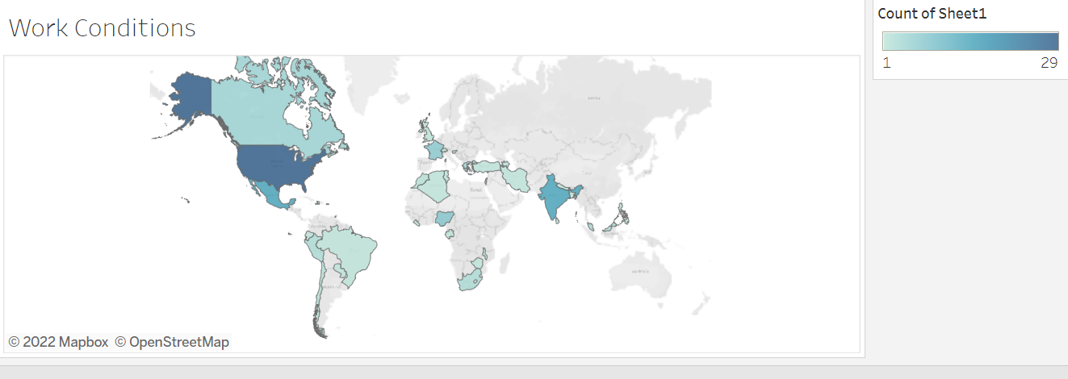
Figure 14: Geographic distribution of media reports of protests mentioning demands related to work conditions. For an interactive version of this map, please click here. Source: Jennifer Johnson
Health worker protests with demands related to work conditions were reported in 35 countries. 29 protests were reported in the United States, followed by 15 in India and Mexico respectively. 8 protests were reported in Nigeria, and 7 in France.

Health System Critique

47 protests mention health system critiques (11%), of which 8 only mention health system critiques. Demands in these categories included poor handling of pandemic, negligence of hospital directors, underreporting of COVID-19 cases and deaths, budget cuts, misuse of funds, and government neglect. In Mexico City, health workers stopped traffic on a highway in protest of negligence from the government and health system. “We demand a federal audit because we know there is equipment, but they don’t deliver it. We ask for the IMSS (National Health System) to intervene,” (El Universal). In Sierra Leone, health workers protested the misuse of funds for the coronavirus response in the country (Al Jazeera). In Slovenia, nursing home employees protested government neglect. "We will not remain silent while (the authorities), using the coronavirus as a cover, try to transform care homes into cheap nursing hospitals,” (France 24).
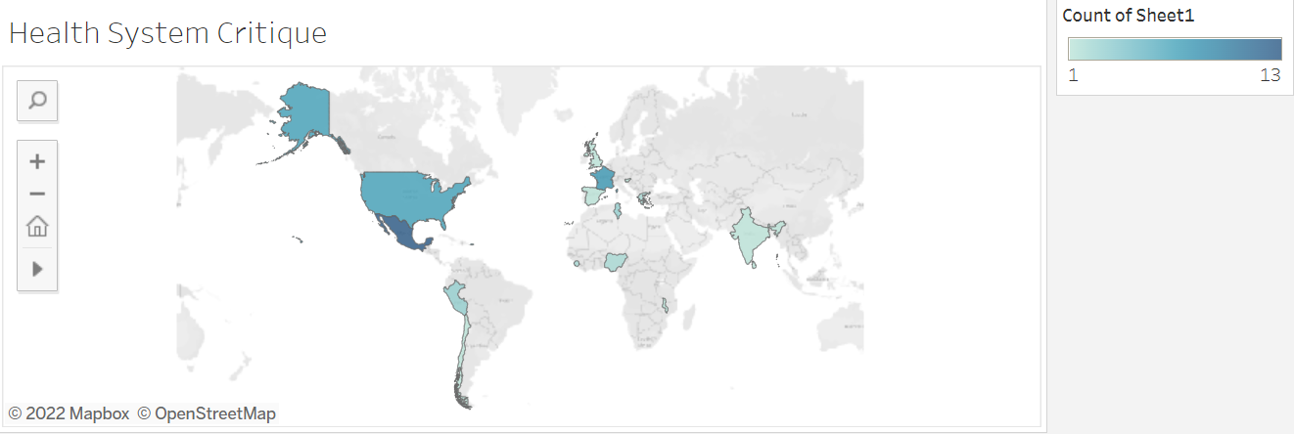Figure 15: Geographic distribution of media reports of protests mentioning demands related to health system critiques. For an interactive version of this map, please click here. Source: Jennifer Johnson

Health worker protests with demands including health system critiques were reported in 15 countries, including Chile (1 report), France (8 reports), Greece (2), India (1), Malawi (1), Mexico (13), Nigeria (2), Peru (3), Sierra Leone (3), Slovenia (1), Spain (1), Sri Lanka (1), Tunisia (3), United Kingdom (1) and the United States (7).

Social Issues

Of all 397 health worker protests, 31 protests mention social issues (7.8%). Of these protests, 29 mention social issues alone, and no other demands. The two main causes of the social issue protests found in my dataset were the Black Lives Matter (BLM) protests in the United States, and the anti-military coup movement in Myanmar.
BLM accounted for 17 of the 31 social issue protests (54%). These protests, also called “White coats for black lives”, aimed to draw attention to the systemic racism faced by people of color in the United States, as well as systemic racism in health care. Many of the protests involved kneeling silently in memory of George Floyd, and African American man who was killed by police officers. The protests often lasted exactly 8 minutes and 46 seconds, the length of time a police officer kneeled on George Floyd’s neck, ultimately killing him. The protests called not only for police to take accountability for George Floyds death, but also to put an end to all forms of systemic racism.
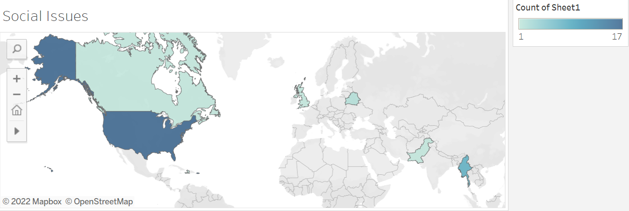
Figure 20: Geographic distribution of media reports of protests mentioning demands related to social issues. For an interactive version of this map, please click here. Source: Jennifer Johnson

Social issues protests were reported in 7 countries, most notably the United States with 17 protests with demands including social issues, all related to the Black Lives Matter protest movement, and Myanmar, with 8 reported health worker protests related to the anti-coup protests held and led by health workers after the military took over the country in early 2021. Other countries that reported health worker protests with demands including social issues were Belarus (2 reports), Canada (1 report), Haiti (1 report), Pakistan (1 report) and the United Kingdom (1 report).

SOCIAL ISSUES
Country | Health Profession | Quote
United States | Health Workers | “What’s happening right now as far as the racial injustice and equality and police brutality, that is also a pandemic. And we need to treat it as such. It starts with us doing this. We have to do better."
United States | Health Workers | “Kneeling on someone’s throat while he cries out ‘I can’t breathe is a public health crisis. This is not a political statement. This is an event to recognize the racism. This is to show our desire to end racial discrimination in medical care.”
United States | Health Workers | “There is a need to stand up and advocate for an entire population in our community. Because black lives matter and there is a disparity in the way they are treated. As health care professionals. I don’t think that anyone can watch the video of what happened to George Floyd and not feel a sense of urgency, and feel the need to go through the screen and resuscitate.”
United States | Medical professionals | "People talk about privilege and using their privilege and the white coat is definitely an example of that. I think people have a respect for our profession and for the white coat as a symbol. I think we need to use that to fight for what's right and try to do something in this moment.”
United States | Doctors, medical students and others | “I think it’s important that we all recognize this is our platform, this is our chance to fight systemic racism and institutionalized racism. And just standing up, this is a chance to use our platform as doctors, as allies. This is it. And if you don’t stand up now, I don’t know when you will.”
United States | Health Workers | “We want to come out to show support for the same community that showed support for us not too long ago as we were on the front lines of the COVID crisis,” said Morin, adding that he thought it was particularly important for him to be visible as a black, male nurse.
United States | Health Workers | "George Floyd could have been me. Being a doctor, being a hospital worker, that might not have protected me from the same fate that happened to George Floyd. I'm here as black man, I'm here as a frontline provider. I'm here with pain. I'm here with hurt, I'm here with anger. But when I look out at this crowd, I know I'm not here alone."
United States | Health Workers | "Over the course of our history, racism has shown that it is truly the root cause of mortality and morbidity in the United States. It is truly the public health emergency that has taken more lives than any epidemic."
United States | Health Workers | “We save everyone at their worst time, why are you killing us? When we take off these scrubs, I am a black woman. And you can't ignore, just because of what you do, what's going on in the world. I would like to have that same message be delivered to the police officers: Who are you when you take off that uniform?”

The anti-military coup movement in Myanmar accounted for 8 of the 31 social issue protests (25%). Health workers were actually the first to take to the streets in protest after the military seized control of the country February 1, 2021. They quickly became known for protesting in their hospital uniforms and PPE, red ribbons pinned to their scrubs, and hands in the air in a 3 fingered salute originally inspired by the hunger games movies. “We want to show the world we are totally against military dictatorship and we want our elected government and leader back,” said Dr. Zun Ei Phyu. “We want to show them we will follow only our elected government. Not the military.”

- Government Restrictions

Government restrictions was one of the least mentioned reasons for protesting, with only 15 protests out of 397 (3.7%). Of these, only 7 protests only mention government restrictions. These protest demands included demands to close borders, such as Hong Kong health worker protests calling on the local government to close the border with mainland China, as well as other protests asking governments to repeal emergency health laws, or asking governments to implement a lockdown. “Most doctors and nurses don’t want to strike. We don’t want to affect our patients. But the government leaves us no choice,” said one protesting health worker in Hong Kong (Time). In Bolivia, health workers held protests asking the government to repeal an emergency health law that made it illegal for health workers to go on strike during the pandemic (Yahoo News).
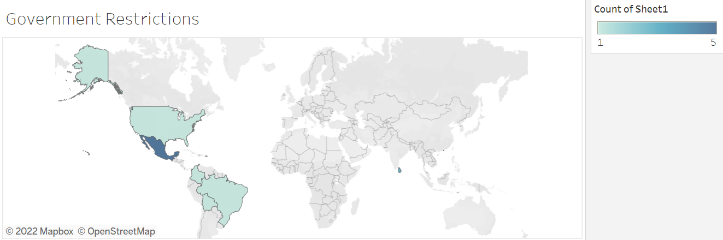
Figure 21: Geographic distribution of media reports of protests mentioning demands related to government restrictions. Source: Jennifer Johnson
Media reports of health worker protests with demands including government restrictions were reported in 7 countries. 5 protests were reported in Mexico, 4 in Hong Kong, 3 in Sri Lanka, and 1 each in Bolivia, Brazil, Colombia and the United States.

Other

12 of the 397 media reports on health worker protests mention “other” demands, the code for demands that call for health worker respect or recognition, or recognition of health workers who have died during the pandemic. In Brazil, a country that has reported one of the highest numbers of nurses’ deaths, health workers stood 6 feet apart in their masks and white coats, holding crosses in memorial to their fallen colleagues. In the United States, the National Nurses United union held a socially distant vigil in front of the White House, laying out 88 pairs of empty white shoes in remembrance of nurses that had died of COVID-19. "If you don't protect us, we can't protect our patients. We remember the thousands of nurses and other healthcare workers that have become infected with COVID-19, and those who have died. We are demanding that the Trump administration and the US Congress listen to these names, all dedicated nurses, who have left families, friends, and colleagues behind. Listen to their names and take action so more nurses don't get sick and die," one nurse said (Business Insider).
In the United Kingdom, a pregnant doctor stood outside of the Prime Ministers office on Downing Street for two hours to protest the death of health workers, holding a placard stating “Protect Healthcare Workers” and wearing her hospital scrubs. “I wanted to show the government, show the public, that this is not OK. And we will not stay silent. These deaths are being normalised. But there is nothing normal about it. It’s become normal not to have PPE or to accept that the guidelines about what’s required is based on supply, not the science. It’s become normal to see healthcare workers dying. But it’s not normal. And we will step up and speak out. It was such a stark difference, standing there in the sunshine. You know the people making decisions are there inside these beautiful buildings. But we are seeing life and death. We are fighting for aprons. Outside, you can believe that everything is OK. I even probably fooled myself – but then you come home and it’s another 800 dead. It’s why I had to do this now… We are being silenced. In our own hospitals. By our own managers. A lot of people are afraid for their own safety but they’re also afraid of losing their jobs. Some of them have visas tied to their work or families to feed. There’s just an awful lot of pressure not to. I thought, who’s going to listen to me? I’m a south Asian woman, a pregnant woman. I thought, ‘Will anyone listen to me?’ But I thought, I just have to at least try,” (The Guardian).
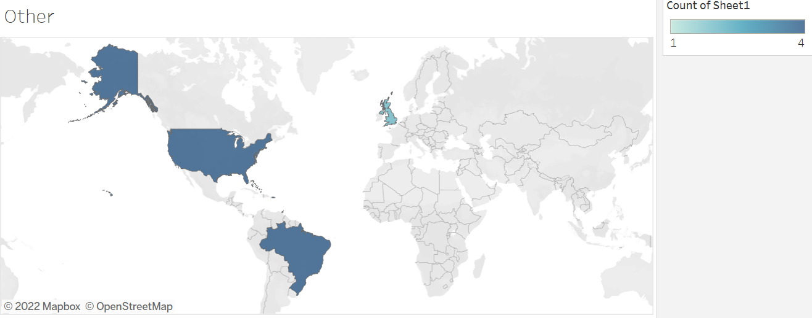
Figure 25: Geographic distribution of media reports of protests mentioning “other” demands, or demands relating to respect or recognition for health workers. Source: Jennifer Johnson
12 health worker protests reported in 5 countries mentioned “other” health worker protest demands, including 4 in Brazil and 4 in the United States. Other countries where protests were reported include the Bahamas (1 report), Trinidad and Tobago (1 report) and the United Kingdom (2 reports).

Delivery Organization

9 media reports on health worker protests mention delivery organizations (2%), of which none only mention delivery organizations. “Delivery organization” refers to health worker demands around conversion to COVID facility, requisition, creation of isolation centers, patient overload, transfer of patients, closures, inclusion in new facility, relocation of unit, staff or patients moved, advanced warning in regard to patients and inclusion in planning processes. In Honduras, nurses protested asking for the creation of a pediatric COVID unit in order to better care for children diagnosed with COVID and to avoid the spread of COVID to other pediatric patients (Proceso Digital).
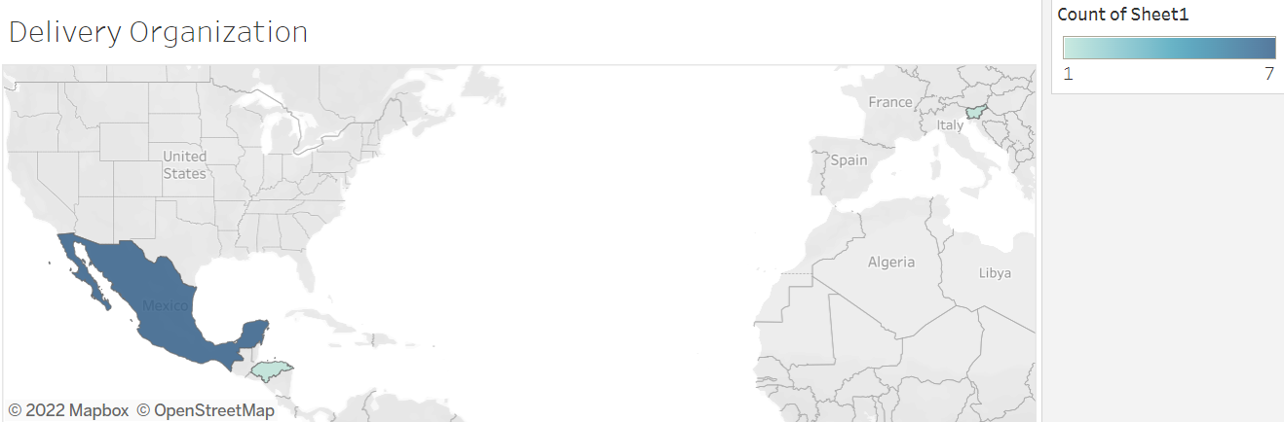
Figure 26: Geographic distribution of media reports of protests mentioning demands related to delivery organization. Source: Jennifer Johnson
Media reports were collected on 9 protests in 3 countries that included demands such as delivery organization. 7 protests were reported in Mexico, followed by 1 protest in Honduras and 1 protest in Slovenia.

Conclusions

The health worker demands found in the media reports collected by the HWP project help us better understand the challenges faced by health workers around the world during COVID-19, and how to better support health workers during this pandemic and beyond. Clear themes and calls for action emerge from the demands:
- Increase production of personal protective equipment (PPE) and increase access for health workers around the world
- Improve compensation for health workers via policy
- Encourage governments, health systems and employers to work on improving working conditions for health workers, and support via policy changes
- Pay attention to and respect the intersectional identities of health workers and the social issues that affect them
- Give health workers a greater voice in policy and governance to directly express their needs, demands and proposals
Health workers are our first line of defense against COVID-19. They play a key role in sustainable development around the world as part of SDG 3, Good Health and Wellbeing. Health worker protests during COVID-19 are not isolated incidents, but rather a symptom of accountability failures in hospital administrations, government, international development and beyond. Ensuring that health workers have the tools, protection and equipment they need to do their jobs safely is crucial in order to end the COVID-19 pandemic and prevent future pandemics as well. To do this, we must listen to and learn from health workers and their global protests.
“Having a nurse who works with COVID-19 patients participate in the hospital’s infectious disease task force would create transparency. You can have administrators at the top making decisions, but it doesn’t always translate to changes in the real world of nursing.” – Nurse, United States (LAist)
These protests allowed health workers to communicate their needs and demands to their governments, hospitals, employers and national health systems – but what if they did not need to leave their hospitals or patients to express their demands? Improving and creating lines of communication between health workers and policy makers would allow health workers to be heard without causing undue stress or sacrificing patient care, and would allow governments and health systems to better support health workers.
Health workers voices matter – they are speaking, are we listening? Listening to and responding to health worker needs and demands, and using their demands to shape policy that better supports them to do their jobs, will be crucial to support health workers and health systems through this current pandemic and future pandemics.

References

Al Jazeera. (2020, July 3). Sierra Leone doctors treating covid-19 patients launch strike. Coronavirus pandemic News | Al Jazeera. Retrieved March 17, 2022, from https://www.aljazeera.com/news/2020/7/3/sierra-leone-doctors-treating-covid-19-patients- launch-strike
Agren, D. (2020). World Report Understanding Mexican Health Worker COVID-19 Deaths. The Lancet 396 (10254): 807. https://doi.org/10.1016/S0140-6736(20)31955-3.
Braun V, Clarke V. Using thematic analysis in psychology. Qual. Res. Psych. 2006; 3: 77– 101.
Brooks Carthon JM, Hatfield L, Brom H, Houton M, Kelly-Hellyer E, Schlak A, Aiken LH. System-Level Improvements in Work Environments Lead to Lower Nurse Burnout and Higher Patient Satisfaction. J Nurs Care Qual. 2021 Jan-Mar 01;36(1):7-13. Doi: 10.1097/NCQ.0000000000000475. PMID: 32102025; PMCID: PMC7483185.
Brophy, S.A., Sriram, V., Zong, H., Andres, C., Paz Mawyin, M., Narayanan G.L. (2022). Heroes on Strike: Trends in Global Health Worker Protests During COVID-19. Accountability Research Center https://accountabilityresearch.org/wp-content/uploads/2022/04/ARC-Accountability- Note_Health-Worker-Protests_WEB.pdf
Business Insider. (2020, April 21). Powerful video shows nurses reading out the names of colleagues killed by coronavirus during a protest in front of the White House. Business Insider. Retrieved March 17, 2022, from https://www.businessinsider.com/video-nurses-protest-names-of- colleagues-died-coronavirus-white-house-2020-4
Copanitsanou P, Fotos N, Brokalaki H. (2017). Effects of work environment on patient and nurse outcomes. Br J Nurs. Feb 9;26(3):172-176. doi: 10.12968/bjon.2017.26.3.172. PMID: 28185485.
Chughtai, A. A., Seale, H., Islam, M. S., Owais, M., & Macintyre, C. R. (2020). Policies on the use of respiratory protection for hospital health workers to protect from coronavirus disease (COVID- 19). International journal of nursing studies, 105, 103567. https://doi.org/10.1016/j.ijnurstu.2020.103567
Daily Sabah. (2020, August 5). Coronavirus infects 24,000 South African health workers. Daily Sabah. Retrieved March 17, 2022, from https://www.dailysabah.com/world/africa/coronavirus-infects- 24000-south-african-health-workers
El Universal. (2020, July 4). Médicos del Imss Se Manifiestan en Naucalpan; Exigen Equipo Para Covid. Retrieved March 17, 2022, from https://www.eluniversal.com.mx/metropoli/edomex/medicos- del-imss-se-manifiestan-en-naucalpan-exigen-equipo-para-covid
Essex, R., and Weldon, S. M. (2021). Health Care Worker Strikes and the Covid Pandemic. The New England Journal of Medicine, DOI: 10.1056/NEJMp2103327
France 24. (2020, April 24). Protest at slovenian care homes over government 'neglect'. France 24. Retrieved March 17, 2022, from https://www.france24.com/en/20200424-protest-at-slovenian- care-homes-over-government-neglect
Hennein, R., Lowe, S. (2020). A hybrid inductive-abductive analysis of health workers’ experiences and wellbeing during the COVID-19 pandemic in the United States. PLoS ONE 15(10): e0240646. https://doi.org/10.1371/journal.pone.0240646
Jarrar M, Al-Bsheish M, Aldhmadi BK, Albaker W, Meri A, Dauwed M, Minai MS. Effect of Practice Environment on Nurse Reported Quality and Patient Safety: The Mediation Role of Person- Centeredness. Healthcare (Basel). 2021 Nov 18;9(11):1578. doi: 10.3390/healthcare9111578. PMID: 34828624; PMCID: PMC8618501.
Kaiser Health News. (2020, July 15). Workers filed more than 4,100 complaints about protective gear. some still died. Kaiser Health News. Retrieved March 17, 2022, from https://khn.org/news/osha- investigations-workers-filed-nearly-4000-complaints-about-protective-gear-some-still-died/
LAist. (2020, June 22). Nurses in Torrance protest working conditions at their hospital. LAist. Retrieved March 17, 2022, from https://laist.com/news/nurses-in-torrance-protest-working-conditions- coronavirus
Marshall, M. N. (1996). The key informant technique. Family Practice, 13 (1), pp. 92-98
Mayfield-Johnson, S., Smith, D. O., Crosby, S. A., Haywood, C. G., Castillo, J., Bryant-Williams, D., Jay, K., Seguinot, M., Smith, T., Moore, N., and Wennerstrom, A. (2020). Insights on COVID-19 From Community Health Worker State Leaders, Journal of Ambulatory Care Management: Volume 43 - Issue 4 - p 268-277 doi: 10.1097/JAC.0000000000000351
Mcdougall, R. J., Gillam, L., Ko, D., Holmes, I., and Delany, C. (2020). Balancing Health Worker Well- Being and Duty to Care: An Ethical Approach to Staff Safety in COVID-19 and Beyond. 1–6. https://doi.org/10.1136/medethics-2020-106557.
The Lancet (2020). The plight of essential workers during the COVID-19 pandemic. Lancet (London, England), 395(10237), 1587. https://doi.org/10.1016/S0140-6736(20)31200-9
Oleribe, O.O., Udofia, D., Oladipo, O., Ishola, T.A., Taylor-Robinson, S.D. (2018). Healthcare workers’ industrial action in Nigeria: a cross-sectional survey of Nigerian physicians. Hum Resour Health. 10 17;16(1):54. doi: http://dx.doi.org/10.1186/s12960-018-0322-8 PMID: 30333035
Peoples Dispach (2020, May 1). Nurses in South Africa protest demanding PPE, Income Tax Breaks and Danger Allowance. Peoples Dispatch. Retrieved March 17, 2022, from https://peoplesdispatch.org/2020/05/01/nurses-in-south-africa-protest-demanding-ppe- income-tax-breaks-and-danger-allowance/
Proceso Digital. (2020, May 13). Enfermeras Protestan Exigiendo insumos Para Enfrentar Covid en hospital Catarino Rivas. Proceso Digital. Retrieved March 17, 2022, from https://proceso.hn/enfermeras-protestan-exigiendo-insumos-para-enfrentar-covid-en-hospital- catarino-rivas/
Rehder, K., Adair, K.C., Sexton, J.B. (2021). The Science of Health Care Worker Burnout: Assessing and Improving Health Care Worker Well-Being. Arch Pathol Lab Med 145 (9): 1095–1109. doi: https://doi.org/10.5858/arpa.2020-0557-RA
Reuters. (2020, July 7). Pics: Zimbabwe police arrest nurses protesting over pay. Independent Online. Retrieved March 17, 2022, from https://www.iol.co.za/news/africa/pics-zimbabwe-police- arrest-nurses-protesting-over-pay-50527552
Russo, G., Xu, L., Mcisaac, M., Matsika-claquin, M. D., and Dhillon, I. (2019). Health Workers’ Strikes in Low-Income Countries: The Available Evidence. no. April: 460–67.
Sarin, E., Lunsford, S.S. (2017). “How female community health workers navigate work challenges and why there are still gaps in their performance: a look at female community health workers in maternal and child health in two Indian districts through a reciprocal determinism framework.” Hum Resources for Health, 15:44 https://doi.org/10.1186/s12960-017-0222-3
Shah MK, Gandrakota N, Cimiotti JP, Ghose N, Moore M, Ali MK. Prevalence of and Factors Associated With Nurse Burnout in the US. JAMA Netw Open. 2021 Feb 1;4(2):e2036469. doi: 10.1001/jamanetworkopen.2020.36469. Erratum in: JAMA Netw Open. 2021 Mar 1;4(3):e215373. PMID: 33538823; PMCID: PMC7862989.
Shaw, A., Flott, K., Fontana, G., Durkin, M., and Darzi, A. (2020). No Patient Safety without Health Worker Safety. The Lancet 396 (10262): 1541–43. https://doi.org/10.1016/S0140- 6736(20)31949-8.
Schlak AE, Aiken LH, Chittams J, Poghosyan L, McHugh M. Leveraging the Work Environment to Minimize the Negative Impact of Nurse Burnout on Patient Outcomes. Int J Environ Res Public Health. 2021 Jan 12;18(2):610. doi: 10.3390/ijerph18020610. PMID: 33445764; PMCID: PMC7828279.
The Guardian. (2020, April 20). 'They can't get away with this': Doctor who took protest to no 10. The Guardian. Retrieved March 17, 2022, from https://www.theguardian.com/society/2020/apr/20/coronavirus-doctor-ppe-protest-downing- street-london
The Guardian. (2020, November 21). 'many of us have PTSD': Pennsylvania nurses strike amid covid fears. The Guardian. Retrieved March 17, 2022, from https://www.theguardian.com/us- news/2020/nov/21/us-nurses-strike-coronavirus-fears-pennsylvania
The Press. (2020, June 1). Kaiser Permanente Antioch Nurses Protest Hospital policies on PPE. thepress.net. Retrieved March 17, 2022, from https://www.thepress.net/news/coronavirus/kaiser-permanente-antioch-nurses-protest- hospital-policies-on-ppe/article_be345780-9b85-11ea-ae20-03e1d895adfa.html
The Signal. (2020, June 20). Henry Mayo Nurses hold rally in opposition to staff layoffs, having to reuse PPE. Santa Clarita Valley Signal. Retrieved March 17, 2022, from https://signalscv.com/2020/06/henry-mayo-nurses-hold-rally-in-opposition-to-staff-layoffs- having-to-reuse-ppe/
Time (2020, February 4). Hong Kong medics demand border closure against coronavirus. Time. Retrieved May 17, 2022, from https://time.com/5777285/hong-kong-coronavirus-border-closure-strike/
Vaismoradi, M., Turunen, H., and Bondas, T. (2013). Content analysis and thematic analysis: Implications for conducting a qualitative descriptive study. Nursing and Health Sciences, 15, 398–405.
Van Stekelenburg, J., & Klandermans, P. G. (2009). Social movement theory: Past, present and prospect. In I. van Kessel, & S. Ellis (Eds.), Movers and shakers: Social movements in Africa (pp. 17-44). (African Dynamics; No. 8).
World Socialist Web Site (WSWS). Brazilian Health Care Workers Strike for PPE and risk bonus. World Socialist Web Site. (n.d.). Retrieved March 17, 2022, from https://www.wsws.org/en/articles/2020/06/27/braz-j27.html

