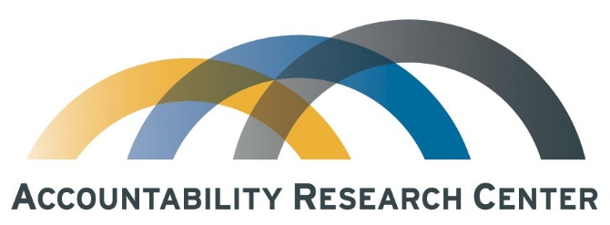

Independent Monitoring of Citizen Engagement Commitments in World Bank Projects

The Accountability Research Center (ARC) is an action-research incubator based in the School of International Service at American University. We collaborate with civil society organizations and policy reformers in the global South to contribute to research and practice in the field of transparency, participation, and accountability (TPA). Our point of departure is that research in the TPA field lags behind practice and is not always seen as relevant by action-strategists—the civil society thinkers and policy reformers who are directly engaged with transforming governance.

We believe that research and learning initiatives that are co-created with action-strategists stand a better chance of contributing to systemic change. Our partnerships involve both a “breadth track” of researcher-practitioner learning exchanges and a “depth track” of more intensive joint action-research incubation. For more on the work of ARC, see www.accountabilityresearch.org.

Announcing a New Opportunity to Collaborate with ARC

ARC’s 18-month project (October 2019 – March 2021) funded by the Open Society Foundations (OSF) supports partnerships between ARC and Southern civil society organizations interested in independent, locally-based, in-depth monitoring of World Bank (WB) citizen engagement (CE) practices. ARC provides modest seed funding and tailored technical support for civil society to monitor CE implementation in WB projects in their home countries. This initiative is informed by ARC-supported exploratory efforts in Colombia, Myanmar, the Philippines and Uganda.

The goal of these pilot initiatives is to contribute to:
- Strengthening the evidence base for CSO partners’ advocacy with government and the World Bank on whether and how they are carrying out their citizen engagement commitments,
- Generating lessons learned from experience across partners about how to build civil society capacity to monitor World Bank CE practices, and
- Identifying weaknesses in World Bank CE implementation that warrant policy dialogue and more intensive monitoring.

Support available for these pilots starts at $5,000 per partner. For background on ARC’s work assessing citizen engagement commitments, see How Does the World Bank Build Citizen Engagement Commitments into Project Design? Results from Pilot Assessments in Mozambique, Myanmar, Nigeria, and Pakistan.
Questions? Please contact arc@american.edu and we will get back to you.
Ready to propose a collaboration? Please complete the proposal questions on the next page.

Proposal to Accountability Research Center (ARC)
Independent Monitoring of World Bank (WB) Citizen Engagement (CE) Commitments
Please send your proposal to nadelman@american.edu and arc@american.edu.

Organization name:
Organization website:
Point of contact:

- Proposed Collaboration ARC

- What WB projects do you propose to monitor the implementation of CE commitments? Add rows as necessary.
WB Project Title | Brief description | Project Status:  In preparation, Approved, Unknown | WB Project link

- Why did you select this/these project(s)? If multiple projects proposed, explain for each one.

- Who would be involved (organizations, agencies, individuals, communities, etc.)? How would responsibilities be allocated?

- What is your proposed plan for monitoring the identified projects? Please discuss the following in your answer: How will you access relevant WB and government documents and data? What are likely travel needs and destinations, who would ideally be consulted? Does your organization have prior relationships/connections to proposed consultees and if not, how would you propose to reach them?

- How would the CE monitoring results/findings be consolidated, utilized and/or disseminated?

- Organizational background

- Does your organization have a civic base or ties to social/civic organizations?

- What is the nature of your organization’s relationship(s) to government? To large donors?

- Related experience

- What kind of monitoring work does your organization do and why (i.e. donor projects, government processes, something else)? How have you previously undertaken monitoring? If so, please include sample of findings.

- Do you have past/current experience monitoring World Bank Projects? If so, please describe.

